NORTH COAST SECTION, CIF
Gil Lemmon, Commissioner of Athletics
5 Crow Canyon Ct., Suite 209, San Ramon, CA 94583 Tel.: (925)263‐2110, Fax: (925)263‐2120
Web:www.cifncs.org; Like Us on Facebook: North Coast Section, CIF; Follow Us on Twitter: @CIFNCS

2017-2018 ELIGIBILITY REVIEW/SUMMARY/PRESENTATION
- Changes for the 2017-2018 school year:
  - Traditional Sport Cheer and Competitive Sport Cheer are now CIF approved sports.
    - Traditional Sport Cheer
      - No season of sport
      - Subject to CIF 504.M – Sunday restrictions, 506 – practice guidelines, transfer rules, eligibility rules for age, number of semesters, academics.
      - Not subject to CIF 600
    - Competitive Sport Cheer
      - Spring season of sport
      - Subject to CIF 504.M – Sunday restrictions, 506 – practice guidelines, transfer rules, eligibility rules for age, number of semesters, academics.
      - Subject to CIF 600
  - 503.B.1 – Uniform Administrative Penalties
    - Penalty for participation of an ineligible athlete
      - First Offense
        - The school will forfeit only the initial game won or tied – same as the current NCS rule (218.A.5)
        - The school will submit to NCS a corrective action plan approved by the principal and the superintendent. (Basically the same as 218.A.1)
        - The school will submit a report at the conclusion of the school year on the actions and corrections made under the action plan. (Basically the same as current NCS policy – 218.A.1)
      - Second Offense – 1-3 above and the school will be prohibited from hosting its first home playoff game in the sport where the forfeiture was applied.
  - Deletion of language concerning athletic motivation
    - Conflict with a coach or school/athletic administration concerning a written or verbal disagreement.
    - Evidence the student’s transfer or change of schools would result in the assurance the student would gain varsity participation.
    - Evidence the student’s transfer or change of schools is believed (objectively or subjectively) to be more competitive or “athletically visible.”
REMEMBER
- When a student transfers:
  - Every transfer student is residentially ineligible until the school has completed and processed an appropriate electronic eligibility application with final review by the NCS Office administrative staff via CIF Home.
  - The enrolling school must provide the student and family the notification - “Notice of Transfer Athletic Rules”.
  - The withdrawing school is asked to provide the same notification upon withdrawal from school.
  - The enrolling school must assist the student and family with the eligibility process. If the student and family are denied eligibility based on CIF Bylaw(s) 202, 207.C or 510 the enrolling school must assist in the appeal process if the student and family choose to appeal. Telling the student and family to call the NCS Office is not assistance and does not fulfill the obligation of the enrolling school to assist the student and family.
  - Not all transfer students will have athletic eligibility granted. Participation is a privilege, not a right. Each transfer case is evaluated based on the CIF eligibility rules and regulations established by CIF member schools.
  - Transfers that are found to violate CIF bylaw 510 may be denied unlimited eligibility in sports participated in the previous 12-calendar year.
  - Transfers made with disciplinary action in place or pending will be denied all levels of athletic eligibility. These denials are not appealable.
  - Every application must be true, accurate, complete, correct and/or not false or fraudulent, CIF bylaw 202. Violation of CIF 202 can make a student ineligible for up to two years.
  - The enrolling school should interview the student and/or family to determine the following:
▪ Did the student make a CIF defined valid change of address?
- Who did the student live with while attending the former school?
- Did the student move with the individual(s) he/she lived with while attending the former school?
- Is there any pre-enrollment contact? The rule states any and all pre-enrollment contact must be reported. Examples: Student shadows at a school, student attends open gym, student attends church with one of your coaches, student went to middle school with other student-athletes at your school, student participated on an outside team that was coached by one of your coaches, or had one or more teammates on the outside team that attend or are transferring to the enrolling school.
- Pre-enrollment contact is only reported when there is pre-enrollment contact with individuals associated with your athletic program.
- Associated is defined as:
  - Persons “associated” with a school include, but are not limited to: current or former coaches, current or former athletes, parent(s)/guardian(s)/caregiver of current or former student/athletes, booster club members, alumni, spouses or relatives of coaches, teachers and other employees, coaches who become employed, active applicants for coaching positions, and persons who are employed by companies or organizations that have donated athletic supplies, equipment or apparel to that school.
- Both the former and enrolling school must report any pre-enrollment contact prior to completion of the enrollment process at the enrolling school. Every transfer student and family complete the CIF Home Parent-Student Certification Form, a form uploaded with every CIF electronic 206 and 207 waiver submitted. The responsibility of the enrolling school is critical in this process. When a student or parent reveal pre-enrollment contact they must sign the certification form correctly and submit an explanation.
- Failure to report pre-enrollment contact may cause the enrolling school to forfeit contests and make the student ineligible for up to two-calendar years.
- Has the student participated on an outside team associated with the enrolling school during the 24 calendar months prior to completion of the enrollment process at your school?
  - If the student has participated on an outside team the Section Commissioner suggests:
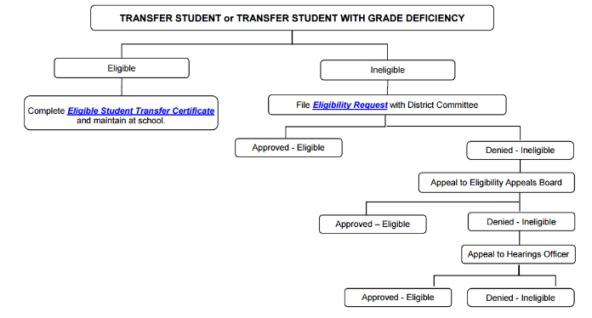
    - Determine the sport and show the student a roster of the students who participated on all of your school’s athletic teams (Frosh, F/S, JV, and Varsity) in the specific sport. Does the student know any of these students?
    - Show the student a list of coaches in the specific sport. Does the student know any of the coaches?
    - Report any pre-enrollment contact determined in the above two bullets.
    - What if the student participated on an outside team but did not participate with any individuals that are associated with the athletic program of your school? Answer – there is no need to report any pre-enrollment contact.
- Did the student transfer from any school within the last 12-calendar months prior to enrolling in School B with disciplinary action in place or pending?
- Did the student attend more than one school in the last 12-calendar months prior to enrollment at your school?
- Is the student in violation of the age limitation rule, maximum number of semesters or academic eligibility rules?
- Based on the above provide the correct transfer form and provide instructions on the completion of the form.
- A CIF defined valid change of address requires the completion of the CIF 206.C.3 electronic eligibility form.
  - The student and family are accountable for providing a true, complete, accurate and correct address change. Reporting a CIF defined valid change of address and not completing one is fraudulent information.
  - May not have any violation of CIF 202, 207.C or 510.
  - May not have any disciplinary action in place or pending at the former school
  - Student meets all other CIF and NCS rules and regulations
  - Enrolling school may evaluate the student’s academic eligibility based on CIF, NCS and their school’s or district’s academic eligibility policy.
  - Electronic waiver application must be approved by the NCS administrative office staff
- CIF Home – 2017-2018 Waivers
  - Student and parent complete the Parent-Student Certification Form.
  - Student and parent confirm the following when they sign the Parent-Student Certification Form:
      - Approve the waiver agreement.
      - No disciplinary action in place or pending at the time of the transfer.
      - Did not play on an outside team associated with the enrolling school.
      - There is no pre-enrollment contact with individuals associated with the athletic program of the enrolling school.
  - Student and parent provide the complete Parent-Student Certification Form to the enrolling school athletic director.
  - Athletic administrator completes the Athletic Director Worksheet, but not required. If you use the worksheet be sure to complete the former school information if the school is not a CIF member, or does not use CIF Home. Within CIF only the Central, San Francisco and Oakland Sections do not use CIF Home.
  - Athletic administrator scans or takes a picture of the Parent-Student Certification Form and saves a copy to be uploaded to the CIF Home site when completing the CIF transfer waiver.
  - School athletic administrator goes to www.cifncshome.org. A link is provided at the NCS website under “Coaches/ Administration” tab at the top of the home page. Click on the tab and a dropdown menu will appear and “School Logon” is the first link” Click on the “School Logon” link.
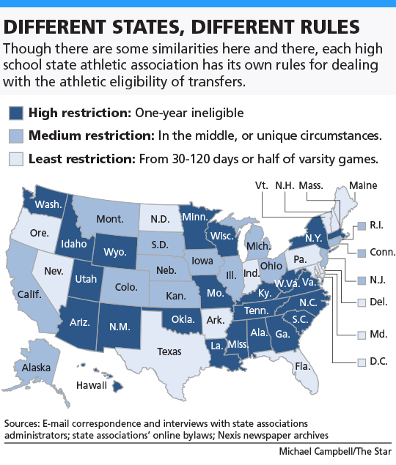
  - Input username and password.
  - On the left side of the “To Do List” page click on “Transfer Forms”
  - Click “Add New”
  - If you need any assistance watch the video provided in the red box in the upper right side of the page, “Need Help on this Page?” Very well done and easy to follow.
  - The following electronic waiver application forms are available:
    - Form 1 - Bylaw 206.C, Valid Change of Residence
    - Form 2 - Bylaw 207.B, Non-Participation, Limited Eligibility, Sit-Out Period, International student not participating in a CIF defined foreign exchange program
    - Form 3 – Bylaw 207.B (5) c. (viii), Hardship Varsity Eligibility
    - Form 4 – Bylaw 208.A, Foreign Exchange Students (approved program)
  - The athletic administrator selects the correct electronic waiver to complete.
  - Once on the selected electronic waiver form, all boxes, click marks, notes, uploads are completed and once the waiver is complete there are two choices:
    - Save the electronic waiver to complete at another time.
    - Submit the electronic waiver for processing.
  - Once submitted the form is automatically forwarded to the former school(s).
  - If the transfer is from a non-CIF member school or a Section who does not use CIF Home do the following:
    - Once the electronic waiver is completed “Send” the waiver to the former school by clicking on “Send” at the bottom of the page.
    - Go back to the “Transfer Forms” or “To Do List” page.
    - Scroll to the sent waiver, where the status should say “Pending Former School(s) Response.
    - Click on the View/Edit folder icon.
    - In the upper right corner of the next page click on “View Form”
    - Scroll down to the bottom of the page where it says the name of the former school and you will see a link titled “Former School Request Response”.
    - Copy that link and paste it in an email to the former school.
    - Provide some basic instructions to the school on how to complete the form (basically review form, click Next at bottom of page, answer questions, agree or disagree, type name for digital signature, then Submit, once the person sees the logon page they are done)
  - On the CIF Home “To Do List” all green colored waivers are waivers saved or sent by the enrolling school. All red colored waivers are electronic eligibility waivers that the former school needs to process.
  - When you submit a waiver the former school(s) athletic administrator receives an email alert.
  - When processing eligibility please attempt to process within a five working day period. Complete eligibility as you would want your eligibility cases to be processed, as quickly as possible, but completely and with all school input as required in the process.
  - Once completed and submitted the electronic waiver is forwarded to the NCS Office. The enrolling school will receive an email of change in status, which is reflected on the “To Do List” page of the enrolling school.
  - The Section Office has 20 days to render a decision, conducting any necessary investigation into the transfer.
  - The waiver will be reviewed by the appropriate administrator at the Section Office.
  - When the Section administrator has rendered a decision all parties will receive an email alert of the decision. On the “To Do List” Transfers subject each eligibility case is listed and the status will reflect the final decision, such as “Denied”, SOP, Unlimited, etc.
- The NCS Office does not process eligibility from June 1st to July 31st.
- All eligibility transfer waiver applications received August 1, 2017 or later will be processed per the following timeline.
  - Students planning to participate in a fall sport – August 1st and processed in date order.
  - Students planning to participate in a winter sport but not a fall sport – September 15th and processed in date order.
  - All other students seeking eligibility waivers – October 15th and processed in date order. o This does not preclude NCS staff from working ahead of the scheduled dates, but will prioritize by season of sport.
- Exceptions to eligibility rules are not made because a school does not have a sub-varsity athletic team.
- Determined athletically motivated transfers may be considered prima facie evidence
(“Sufficient evidence”) that the student enrolled in that school in whole or in part for athletic reasons (See Bylaw 200, 206.C., 207.C and 510). Based on the CIF philosophy that the “student attend school to receive an education first; athletic participation is secondary” (Bylaw 200.A.(2), individual Section Offices may limit eligibility for a student when there is evidence the transfer, or move is made to acquire athletic participation at “School B.”
- NCS administrative staff process eligibility transfer waiver applications as follows.
  - Gil Lemmon (gdlemmon@cifncs.org) – all hardship waiver requests, all applications involving potential violation of CIF 510 and applications with last names starting with letters A-D. Commissioner Lemmon also currently reviews all football and basketball transfers.
  - Karen Smith (ksmith10@cifncs.org) – waiver request applications with last names starting with letters E-M and all 213 waivers.
  - Bri Niemi (bniemi@cifncs.org)– waiver request applications with last names starting with letters N-Z.

