To: All De La Salle Football Fans
From: The Athletic Department
Date: August 14, 2017

Welcome to another exciting football season. This season the De La Salle athletic department will offer season passes for fans. These passes are good for one adult, child,
Or senior admission to each home game at a discounted rate. These passes are $40 each
for adults and $25 for children (12 and under) and seniors (60 and over). They are
available for purchase at the bookstore by 8/14/17. The home games for this year are as follows:

- Friday September 1 – St. John’s – Washington, D.C. – 7:30
- Friday September 8 – St. Francis – Mountain View – 7:30
- Saturday September 23 – Central - Fresno – 7:30
- Friday September 29 – Bishop O’Dowd – 7:30
- Friday October 6 – California – 7:00
- Friday November 3 – San Ramon Valley – 7:00

Notes - This pass does not include admission for any playoff games.

Gates open 30 minutes prior to the first game. Varsity game times listed only. This pass also includes admission to all home frosh games. Price of admission for EBAL league games is $8/adults & $5/children and seniors.

Thanks for your support,

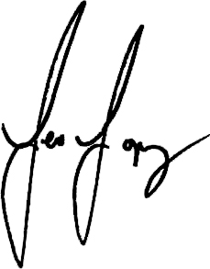

Mr. Leo Lopoz
Athletic Director
925.288.8144
lopozl@dlshs.org

